GitHub And Jenkins Link

# Setting up Github

1. Creating a Repository

Create a public repository

1. Open git CMD in your device
2. Change path to the project.

1. Initialize the git in your directory using *git init*.
2. Add your files to the repository using *git add .*.



1. Now commit the files to the git.

1. At last push the files to the repository.

1. Your files are now deployed to your github repository.

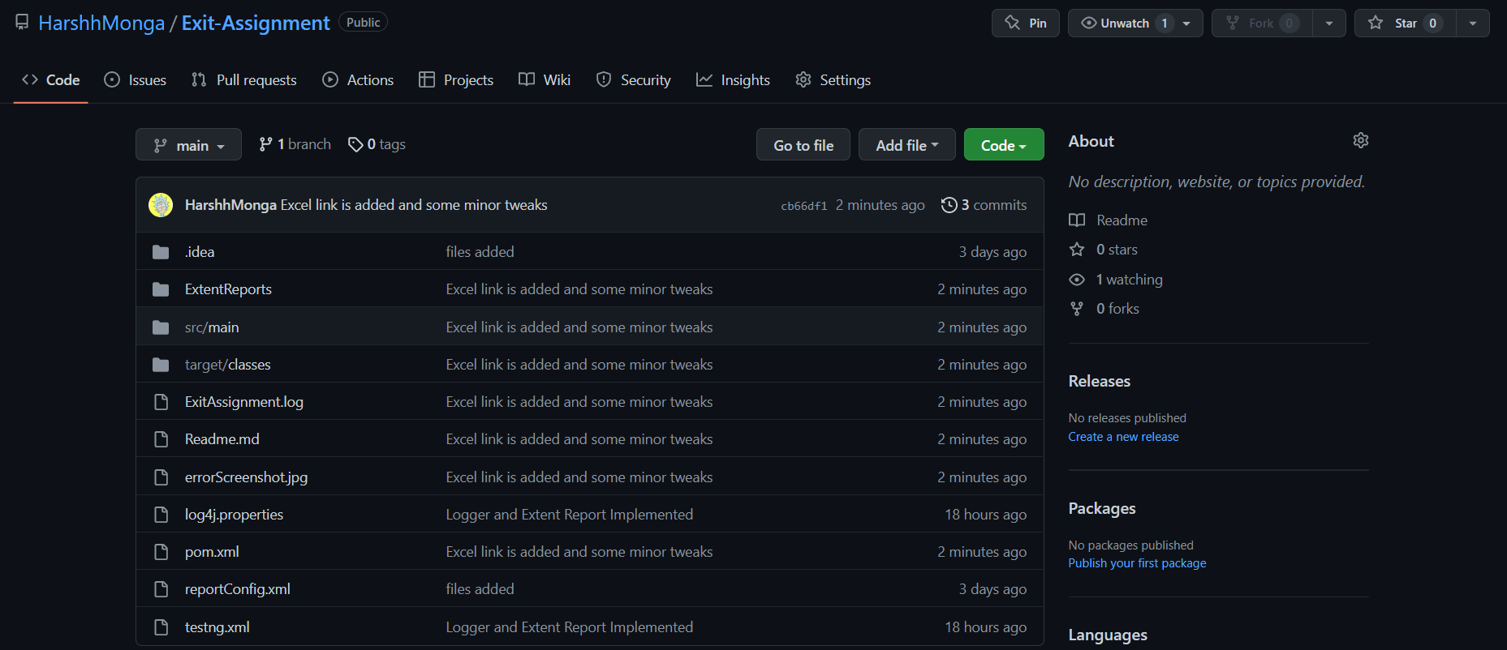

* Setting up Jenkins

1. Goto your Jenkins webpage.

1. Create a new item and select github project and pass the link to you repository.

1. Under source code management select git and pass the repository url and mention the name of the branch you’re working on.

1. In build triggers select GitHub hook trigger for GITScm polling and save the project.

1. At last under the settings of your repository create a webhook and pass the url of your Jenkins under payload url and select content type as application/json and save the webhook.

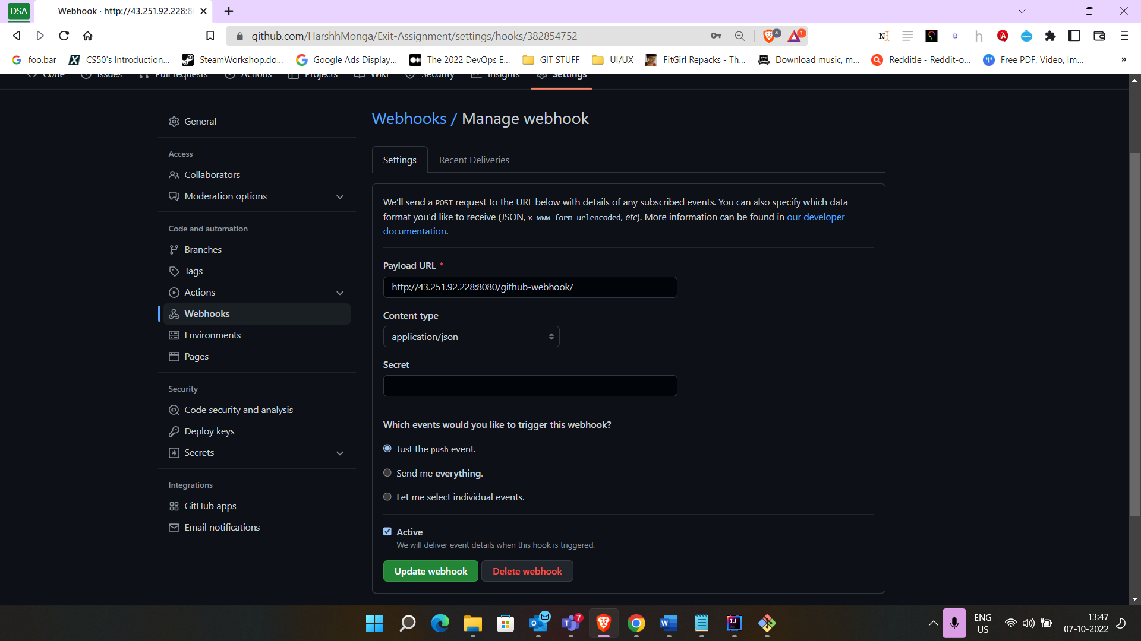

1. Now your github and Jenkins are linked, and at every push event in GitHub triggers the Jenkins.